UFT Findings:

You can find below issues found during UFT execution. Not necessarily they were a step in the test script, but they might have been discovered during system navigation and “negative” testing.

When related to a specific step from the test script, the step will be included.

1. Country field in the Venue screen does not appear for end users, only service coordinators:

When user goes to the Venue screen, the “Country” is shown:

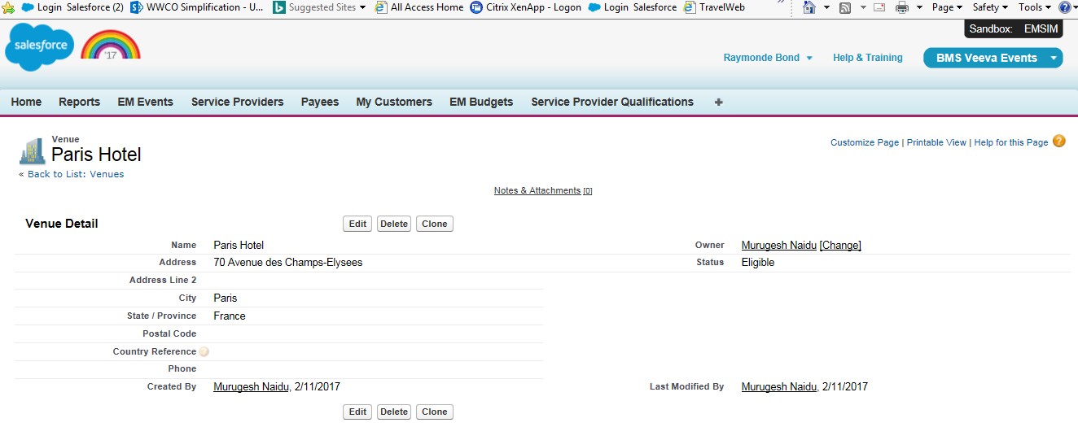

If logged as Event Owner, country is does not appear:

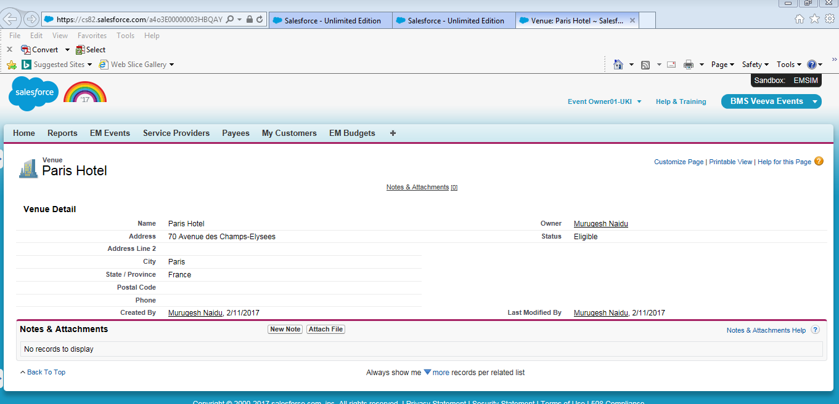

**mnaidu 5/22 - FIXED – UPDATED BASIC PERMISSION SET TO GIVE THIS ACCESS. THIS WAS MISSING PERMISSION IN ALL ENVIRONMENTS.**

1. (RESOLVED) UFT_UK_002 (Step 116) PO approver is included as a Team Member, but system shows error message not recognizing the approver has been added (Resolved by Graham – Generic approver in Veeva didn’t have a BMS id, therefore the error)

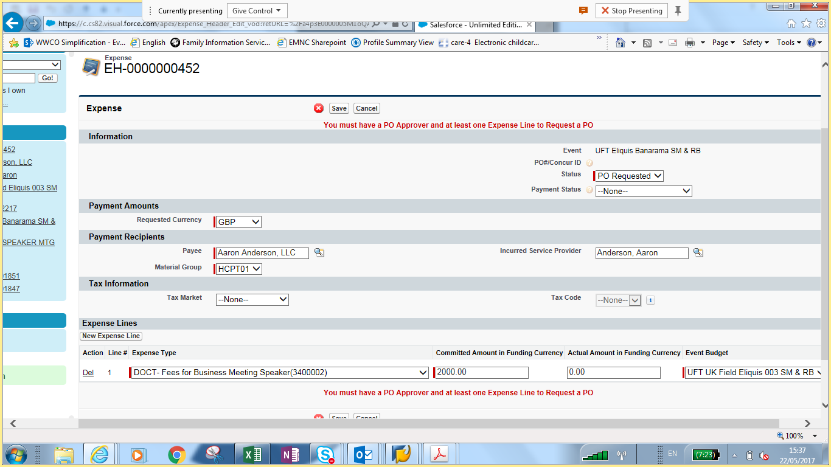

1. UFT_UK_002 (Step 145) Read only user was not able to edit, but it was able to delete the following items: Budget Overview, Event Materials, Attachments

(no screen available)

**Mnaidu – 5/21 – This was a late fix on a Product ticket that we applied today in EUFULL. Now applied to EMSIM as well.**

1. System allows you to select Inactive User when creating a new TASK (it does not allow you to save it though, but users recommend that it should not even show up as an option)

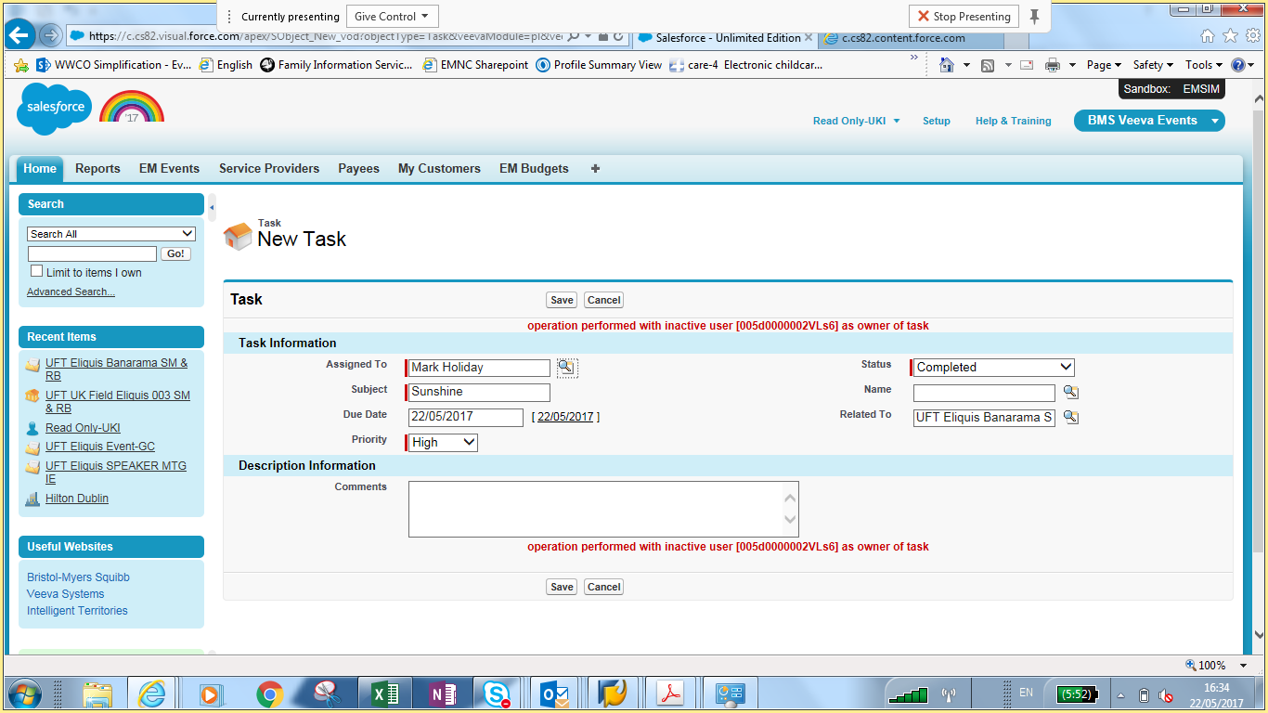

**Mnaidu – 5/21 - Platform behaviour. Cannot be handled with config.**

1. UFT_UK_002 (Step 150) Service Coordinator is not able to unlock an archived event:

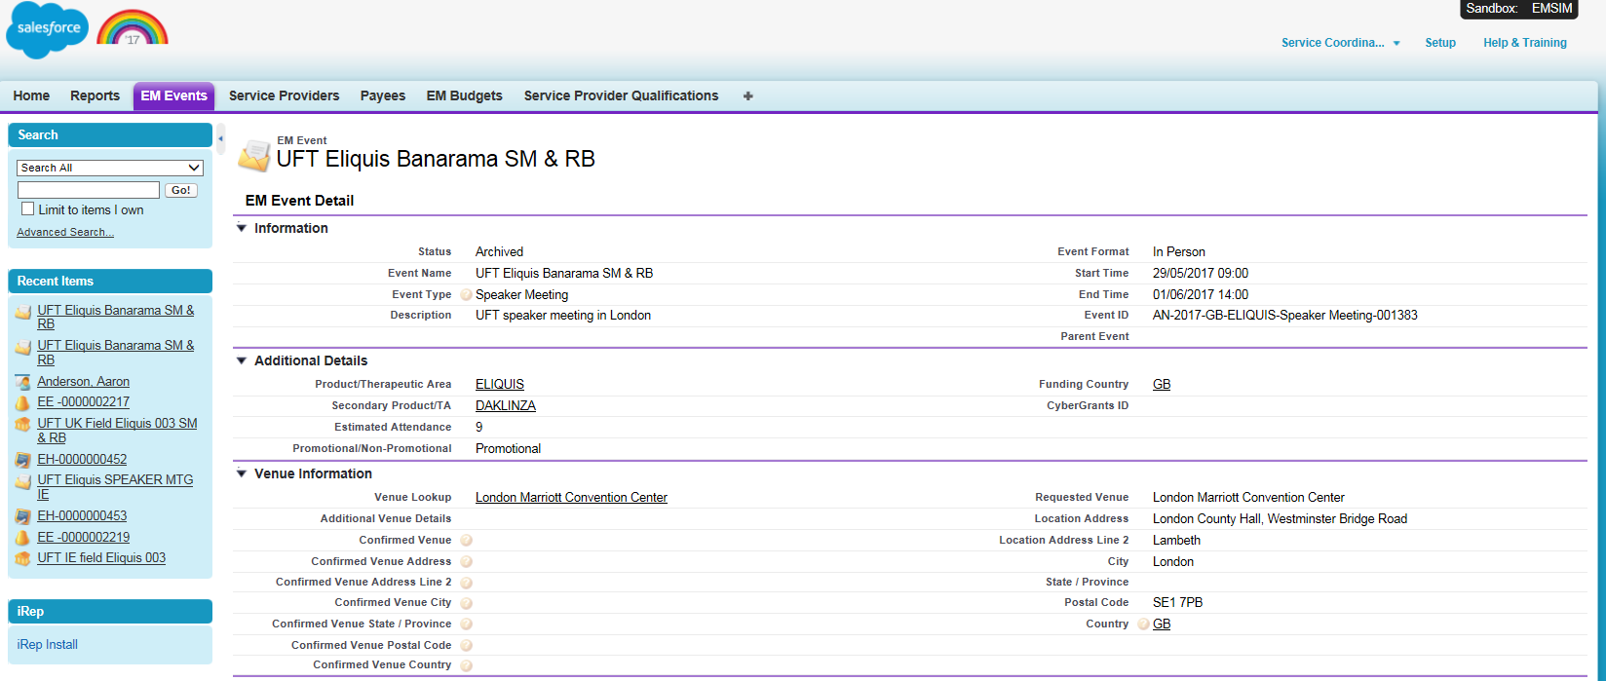

**MNAIDU 5/21 - This meeting has Priya Jadeja added as Service Coordinator. The script assumes however “Service Coordinator01-UKI (**[**ukisc01@bms.com.emsim)**](mailto:ukisc01@bms.com.emsim))**” as the SC. The user with the role of SC can only unlock the Event. I gave SC perm sets to Priya so she has object level accesses for 2.0…and then here is the snapshot showing Priya with Unlock capability.**

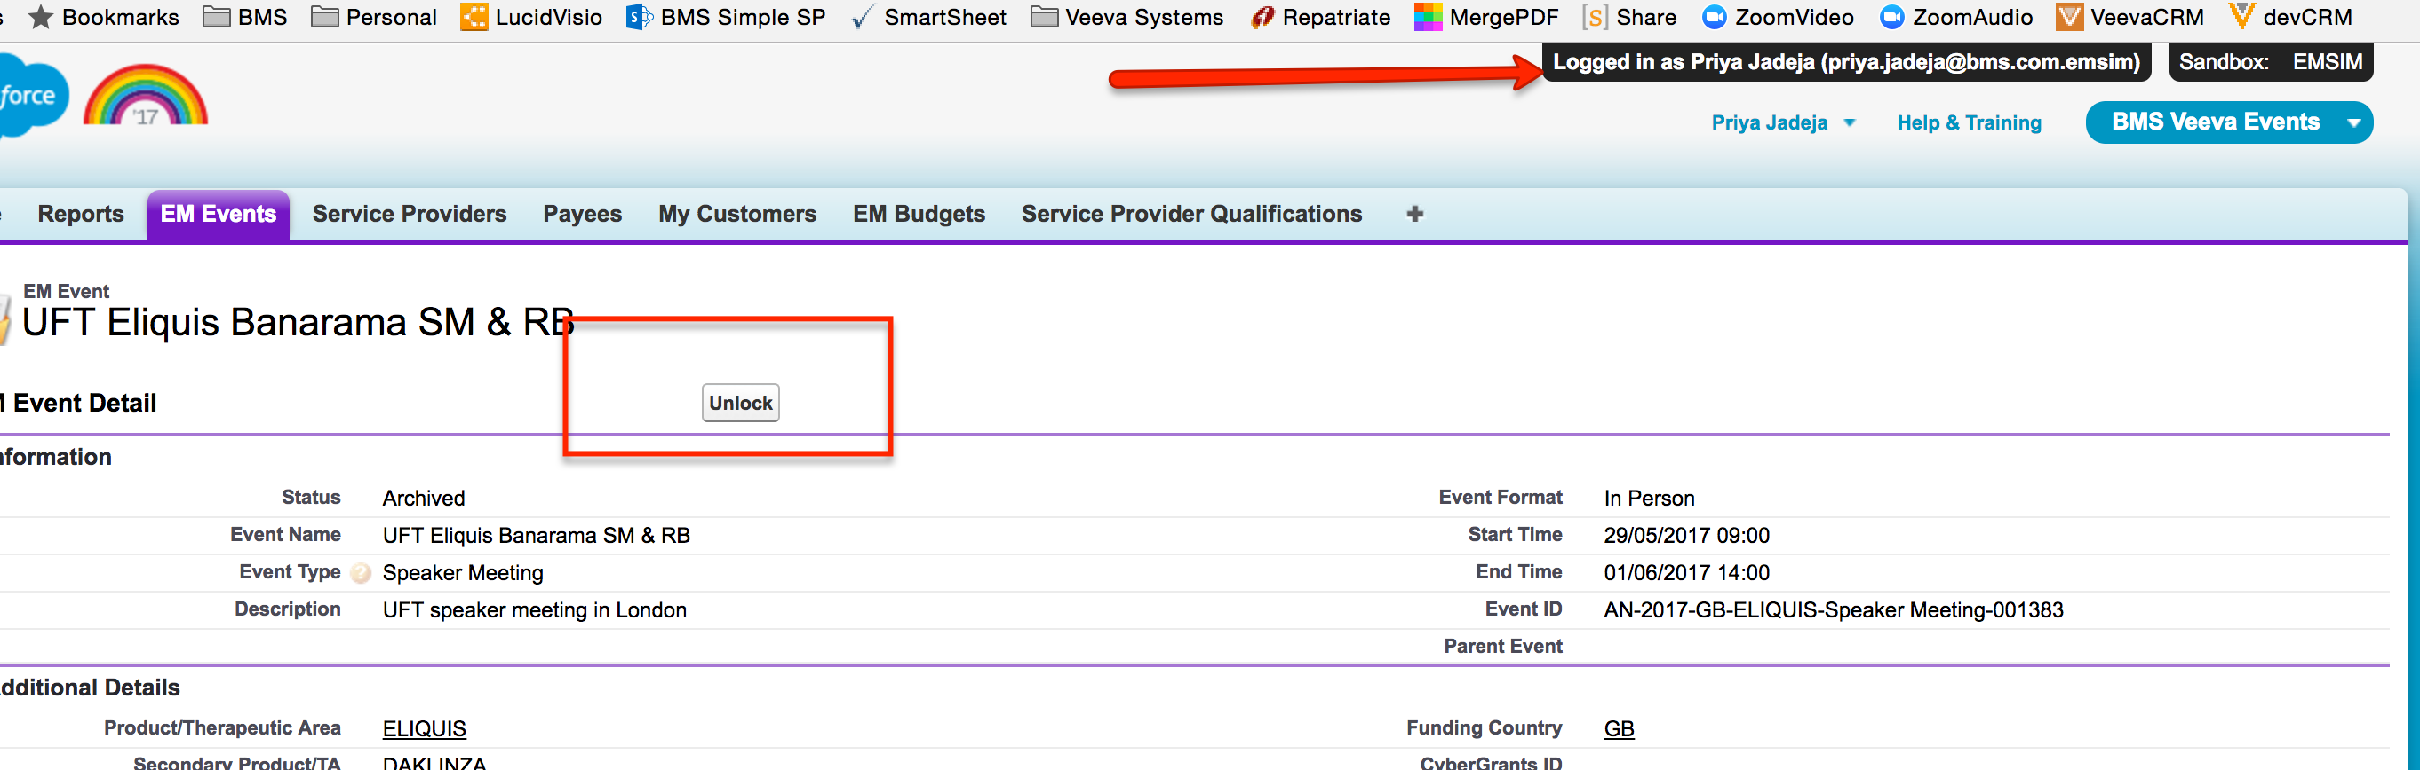

1. UFT_UK_002 (Step 157) Any user is still allowed to delete tasks and attachments in archive status

(no screen available)

**MN – 5/21 - This is correct. However the system should give an error based on CRUD level access you (logged in user) have to the task or attachment.**

1. The actual currency symbol is not shown, just “¤”:

£ for British Pounds and € for Euros

**MN – 5/21 - This is known Interact issue from 1.x**

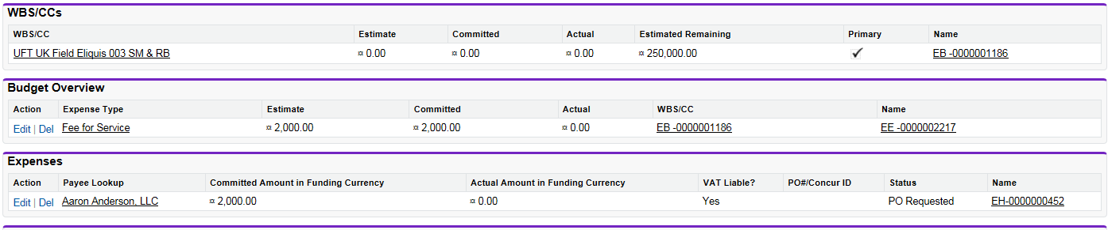

1. Event Header formatting when editing an event does not look good, and also create by and last modified by is not being shown (screen not captured during UFT, but taken from a random activity in EMSIM):

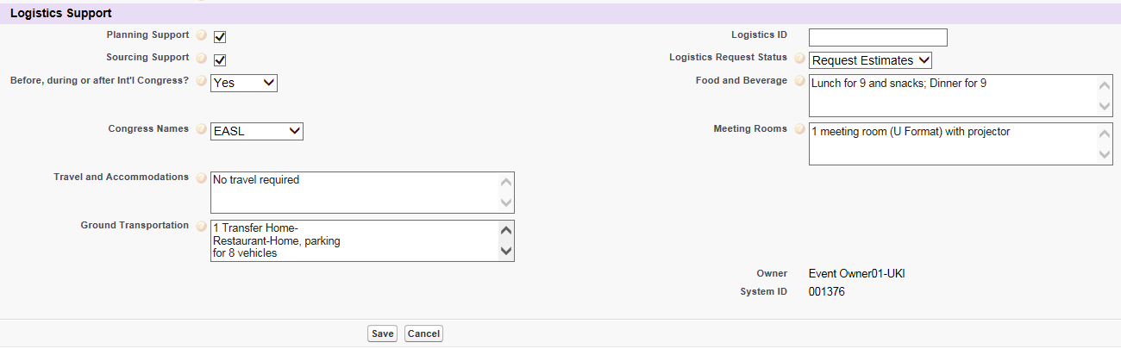

Create by & Modified by does not appear

Can we align the fields?

**MN – 5/21 – Please route this request via Pat/Michelle for Enhancement requests**

During the UFT execution, some improvement requests were asked:

1. Attended as default for Walk In

Is it possible to default the status to “Attended” when adding a “walk in”?

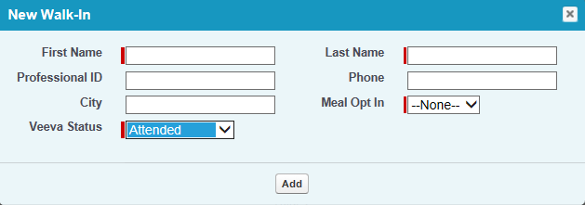

**MN – 5/21 – I believe it was a specific Requirement to not default to any Status value. Please raise issue with Pat/Michelle/Shaheen for requirement modification or enhancement request**

1. Not able to select many attendees at the same time

Event Owner has to select one attendee, then add, then select another one, add again, etc. System should allow multi-selection.

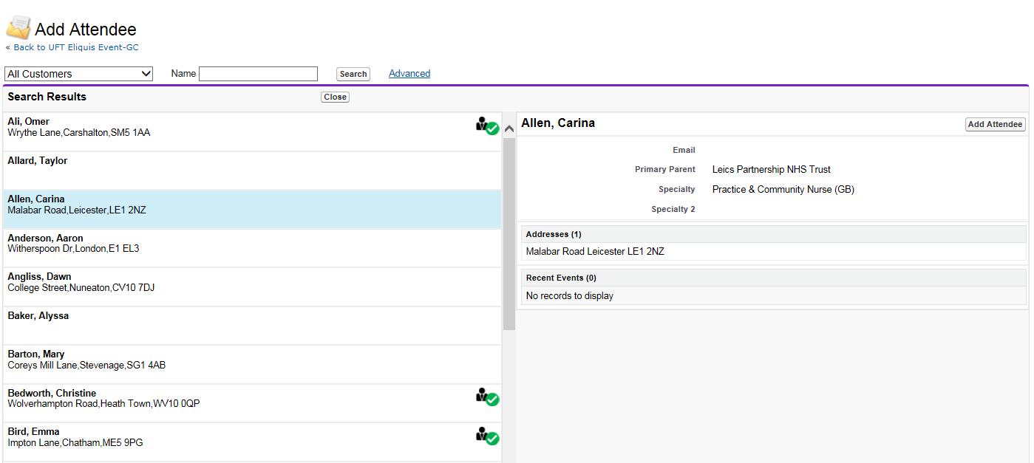

**MN – 5/21 – This is Product limitation as of this release.**